Bean, Bean Lifecycle and Scope
In the world of the Spring Framework (Java), Beans, Scopes, and Lifecycles sound complicated, but they are actually easy to understand if we use a simple analogy: A Robot Factory.
Imagine Spring is a smart Robot Factory manager. You tell the manager what kind of robots you need, and the manager builds them, delivers them, takes care of them, and throws them away when they are no longer needed.

1. What is a Bean?
A Bean is simply an object (a Java object) that is created, managed, and assembled by the Spring container (the Factory).
- Without Spring: You have to build objects manually using the new keyword everywhere (Car myCar = new Car();). If Car needs an Engine, you have to build that too. It gets messy.
With Spring (Beans): You tell Spring, "Hey, I need a Car bean," and Spring automatically builds the Car, attaches the Engine to it, and hands it to you ready to drive.
The shortest summary of the difference is: All Spring beans are objects, but not all objects are Spring beans. [1]
A Java Object is any standard instance of a class that you instantiate manually in code, whereas a Spring Bean is a Java object that is specifically created, configured, and managed by the Spring Inversion of Control (IoC) container. [1, 2]
Direct Comparison
Feature | Java Object | Spring Bean
Creation | Manually instantiated by you using the new keyword. | Automatically instantiated by the Spring IoC container.
Management | Handled by you; subject to standard JVM Garbage Collection. | Lifecycle (creation, initialization, destruction) is entirely managed by Spring.
Dependency Injection | You must manually pass dependencies via constructors or setters. | Spring automatically wires and injects required dependencies (via @Autowired).
Scope Context | Exists standalone within the standard Java Runtime Environment (JRE). | Exists specifically inside the ApplicationContext container of the Spring Framework.
Declaration | Written as a plain Java class (POJO). | Defined using annotations like @Component, @Service, or methods marked with @Bean.
Code Example
1. Normal Java Object:
java
// You control the instantiation and management manually
Engine engine = new Engine();
Car myCar = new Car(engine);
Use code with caution.
2. Spring Bean:
java
@Component
public class Car {
@Autowired
private Engine engine; // Spring automatically creates and injects the Engine object
}
Use code with caution.
By letting Spring turn your normal objects into "Beans," you gain access to powerful framework features like loose coupling, automated testing utilities, and pre-configured lifecycle phases (like executing setup code right after the object is built). [1]
Are you currently troubleshooting a dependency injection issue, or are you trying to decide whether a specific class in your project should be registered as a Spring @Component? Let me know what you are building! [1]

2. What is Bean Scope?
Scope tells Spring how many copies of a bean should be made and how long they should live.
Here are the two most common scopes using a simple office analogy:
Scope | What it means | Simple Analogy
Singleton (Default) | Spring creates only one instance of the bean for the entire application. Every time you ask for it, Spring gives you the exact same object. | The Office Coffee Machine: Everyone in the office shares the exact same machine.
Prototype | Spring creates a brand-new instance every single time someone asks for it. | A Paper Coffee Cup: Every time someone wants coffee, they get a brand-new, unique cup.
(Other scopes like Request, Session, and Application exist mainly for web apps, where beans live as long as a web request or browser session lasts.)
In the Spring Framework, a bean scope determines the lifecycle, creation timing, and visibility of a bean instance within the Spring IoC Container. [1, 2]
Core Bean Scopes
- Singleton (Default):
  - Creates a single shared instance per IoC container.
  - Cached in memory and reused for every subsequent request.
  - Best suited for stateless beans. [1, 2, 3, 4, 5]
- Prototype:
  - Creates a brand-new instance every time the bean is requested or injected.
  - Spring does not manage the full lifecycle of prototype beans after creation.
  - Best suited for stateful beans. [1, 2, 3, 4]

Web-Aware Bean Scopes
Available only when using a web-aware ApplicationContext. [1, 2, 3]
- Request:
  - Creates a new instance for a single HTTP request.
  - Disposed when the HTTP request completes. [1, 2]
- Session:
  - Creates a new instance for an entire HTTP session.
  - Disposed when the HTTP session times out or ends. [1, 2]
- Application:
  - Creates a single instance for the lifecycle of a ServletContext.
  - Shared across multiple HTTP servlet requests. [1, 2]
- WebSocket:
  - Creates an instance tied to the lifecycle of a WebSocket session. [1, 2]
If you'd like, I can provide:
- Code examples using the @Scope annotation
- How to handle injecting a prototype bean into a singleton bean safely
Let me know how you would like to proceed!

3. What is the Bean Lifecycle?
The Lifecycle is the journey of a Bean from the moment it is born until the moment it is destroyed.
Think of a robot's life in the factory:
- Instantiation (Birth): Spring reads your configuration and creates the object (calls the constructor).
- Populating Properties (Setup): Spring injects any required dependencies (like giving our Robot arms and tools).
- Initialization (Ready for work): Spring runs any custom setup methods you've defined (equivalent to the robot booting up its operating system and saying, "Systems online!").
- In Use: The bean does its job in your application.
- Destruction (Cleanup): When your application shuts down, Spring runs cleanup methods (equivalent to the robot saving its data and powering down safely before being recycled).
- Here is a simple, real-world Java example using Spring annotations to bring our Robot Factory analogy to life.
- We will create a Robot bean, set its scope to Prototype, and use lifecycle annotations to watch it boot up and shut down.

The Java Code Example
- Java
- import jakarta.annotation.PostConstruct;
- import jakarta.annotation.PreDestroy;
- import org.springframework.context.annotation.Scope;
- import org.springframework.stereotype.Component;

- // 1. @Component tells Spring: "Make this class a Bean managed by the factory!"
- @Component
- // 2. @Scope("prototype") tells Spring: "Build a brand new Robot every time someone asks for one."
- @Scope("prototype")
- public class Robot {

- // STEP 1: Instantiation (Constructor)
- public Robot() {
- System.out.println("-> [Birth] Robot body is being built!");
- }

- // STEP 3: Initialization (@PostConstruct runs right after dependencies are injected)
- @PostConstruct
- public void turnOn() {
- System.out.println("-> [Setup] Robot systems are online and ready!");
- }

- // STEP 4: In Use
- public void work() {
- System.out.println("-> [Action] Robot is assembling parts on the conveyor belt.");
- }

- // STEP 5: Destruction (@PreDestroy runs right before the bean is destroyed)
- @PreDestroy
- public void shutDown() {
- System.out.println("-> [Cleanup] Robot is powering down and saving logs!");
- }
- }

What Happens When You Run It?
- If you ask Spring for two separate Robot beans in your main application:
- Java
- // Spring builds Robot #1
- Robot robot1 = context.getBean(Robot.class);
- robot1.work();

- // Spring builds Robot #2 (because scope is prototype)
- Robot robot2 = context.getBean(Robot.class);
- Your console will print out the exact lifecycle journey:
- Plaintext
- -> [Birth] Robot body is being built!
- -> [Setup] Robot systems are online and ready!
- -> [Action] Robot is assembling parts on the conveyor belt.

- -> [Birth] Robot body is being built!
- -> [Setup] Robot systems are online and ready!
- Note: If you change @Scope("prototype") to @Scope("singleton"), Spring will build the robot only once. The second time you ask for a robot, it will give you robot1 again without printing the birth/setup messages a second time!

The @Bean annotation is a method-level flag used to tell Spring: "Hey, I am going to manually instantiate this object inside this method using new, but I want you to intercept the return value, register it, and manage it as a Spring Bean inside your container." [1, 2, 3, 4]
It is the foundation of Java-based configuration in Spring. Instead of letting Spring auto-scan your classes, @Bean gives you explicit control over the creation process. [1, 2, 3]
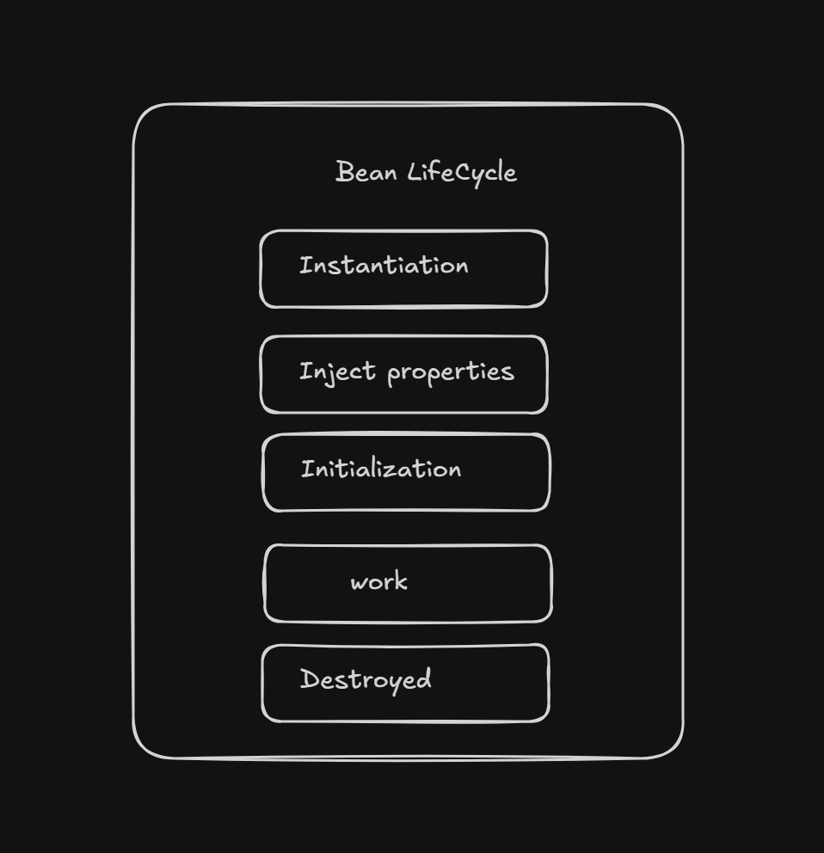

The Direct Comparison: @Bean vs @Component
Spring gives you two primary ways to create a bean, and they serve different purposes: [1, 2]
Feature | @Component (Class-level) | @Bean (Method-level)
Where it goes | Placed on top of a Class. | Placed on top of a Method inside a @Configuration class.
Control | Implicit. Spring scans the project, finds the class, and builds it using default constructors. | Explicit. You write the custom instantiation logic (new MyObject()) inside the method.
Third-Party Libraries | No. You cannot add @Component to a class inside a JAR file because the code is read-only. | Yes! You can wrap third-party classes inside a @Bean method to turn them into Spring beans.

Code Example: How @Bean Works
You typically place @Bean methods inside a dedicated configuration class annotated with @Configuration: [1, 2]
java
import org.springframework.context.annotation.Bean;
import org.springframework.context.annotation.Configuration;
import org.springframework.web.client.RestTemplate;

@Configuration // Tells Spring this class contains bean definitions
public class AppConfig {

// 1. Managing a Third-Party Object
@Bean
public RestTemplate restTemplate() {
// We don't own the RestTemplate class, but now Spring manages it!
return new RestTemplate();
}

// 2. Customizing Instance Logic
@Bean(name = "premiumCar") // You can optionally give the bean a custom name
public Car premiumCar() {
Engine V8Engine = new Engine("V8");
Car luxuryCar = new Car(V8Engine);
luxuryCar.setSunroof(true); // Explicit custom setup
return luxuryCar;
}
}
Use code with caution.
When should you use @Bean?
- Integrating Third-Party Libraries: If you want to use external tools like RestTemplate, ObjectMapper (Jackson), or database data sources as inject-ready components. [1, 2, 3]
- Conditional or Complex Custom Setup: When creating an object requires heavy setup logic, reading specific environment properties, or executing logic that a simple constructor cannot handle. [1, 2]
- Decoupling Configuration: Keeping your business logic classes "clean" and placing all wiring infrastructure code in one centralized configuration location. [1]
Are you trying to expose a third-party library class as a bean, or are you trying to resolve an ambiguity issue (like having two beans of the identical class type)? Let me know your exact use case! [1, 2]

The fundamental difference is that a method marked with @Bean registers its return value in the Spring container, whereas a normal method just executes logic and returns a standard Java object that Spring knows nothing about.
When you call a @Bean method inside a @Configuration class, Spring intercepts the call. Instead of running the method again to create a brand-new object, it returns the already managed, singleton instance from its container.

The Direct Comparison
Feature | Method with @Bean | Normal Java Method
Spring Awareness | Yes. The returned object becomes a managed Spring Bean. | No. The returned object is a standard Java object.
Invocation Behavior | Intercepted. Spring wraps the call. Multiple calls to the method return the exact same instance (by default). | Standard. Every call executes the code from scratch and creates a fresh object every time.
Dependency Injection | Supported. The returned object can be @Autowired into other classes. | Unsupported. Other classes cannot automatically inject this object.
Location | Must be placed inside a @Configuration class (or a component class). | Can be placed in any class anywhere in your codebase.

The @Bean annotation is a method-level flag used to tell Spring: "Hey, I am going to manually instantiate this object inside this method using new, but I want you to intercept the return value, register it, and manage it as a Spring Bean inside your container." [1, 2, 3, 4]
It is the foundation of Java-based configuration in Spring. Instead of letting Spring auto-scan your classes, @Bean gives you explicit control over the creation process. [1, 2, 3]

The Direct Comparison: @Bean vs @Component
Spring gives you two primary ways to create a bean, and they serve different purposes: [1, 2]
Feature | @Component (Class-level) | @Bean (Method-level)
Where it goes | Placed on top of a Class. | Placed on top of a Method inside a @Configuration class.
Control | Implicit. Spring scans the project, finds the class, and builds it using default constructors. | Explicit. You write the custom instantiation logic (new MyObject()) inside the method.
Third-Party Libraries | No. You cannot add @Component to a class inside a JAR file because the code is read-only. | Yes! You can wrap third-party classes inside a @Bean method to turn them into Spring beans.

Code Example: How @Bean Works
You typically place @Bean methods inside a dedicated configuration class annotated with @Configuration: [1, 2]
java
import org.springframework.context.annotation.Bean;
import org.springframework.context.annotation.Configuration;
import org.springframework.web.client.RestTemplate;

@Configuration // Tells Spring this class contains bean definitions
public class AppConfig {

// 1. Managing a Third-Party Object
@Bean
public RestTemplate restTemplate() {
// We don't own the RestTemplate class, but now Spring manages it!

return new RestTemplate();
}

// 2. Customizing Instance Logic
@Bean(name = "premiumCar") // You can optionally give the bean a custom name
public Car premiumCar() {
Engine V8Engine = new Engine("V8");
Car luxuryCar = new Car(V8Engine);
luxuryCar.setSunroof(true); // Explicit custom setup
return luxuryCar;
}
}
Use code with caution.
When should you use @Bean?
- Integrating Third-Party Libraries: If you want to use external tools like RestTemplate, ObjectMapper (Jackson), or database data sources as inject-ready components. [1, 2, 3]
- Conditional or Complex Custom Setup: When creating an object requires heavy setup logic, reading specific environment properties, or executing logic that a simple constructor cannot handle. [1, 2]
- Decoupling Configuration: Keeping your business logic classes "clean" and placing all wiring infrastructure code in one centralized configuration location. [1]

